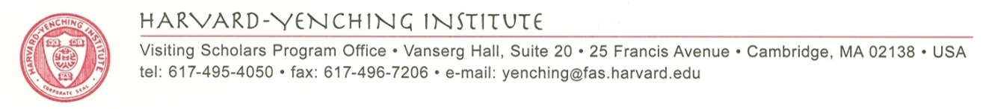

HARVARD-YENCHING INSTITUTE SOUTH ASIAN STUDIES
FELLOWSHIP PROGRAM ANNOUNCEMENT
(2019-20)

September 5, 2018

Dear Colleagues,
Thank you very much for nominating candidates to the Harvard-Yenching Institute South Asian Studies in China fellowship program in the past three years. We are now back in touch again to continue this annual nomination and selection for this new Harvard-Yenching Institute fellowship program as the Harvard-Yenching Institute continues our efforts in developing with Sichuan University and four other universities in China, I am writing to announce that this new HYI program is inviting nominations and applications from younger scholars in five universities in China. For the 2019-20 academic year, the Harvard-Yenching Institute plans to select a few outstanding young scholars (including doctoral students and young faculty who completed their doctorate within the past 5 years) in the field of South Asian Studies to come to the HYI for a one-year research stay. We would greatly appreciate if you could nominate two candidates to this program. If a selected candidate is a doctoral student, the HYI will offer a fellowship for the student to come as a visiting fellow affiliated with the Graduate School of Arts and Sciences and the Harvard-Yenching Institute. If a candidate is a young faculty with a doctorate, we will offer a grant for the faculty member to come as a visiting scholar. The study and research of a candidate should be related to South Asian Studies in the field of humanities and social sciences. There is no specific age limit, but we strongly prefer younger scholars in a crucial stage of their career growth and development. we welcome nominations in all social science and humanities areas of Indian studies.

Attached please find an application form. In addition, an applicant should provide three letters of recommendation. After initial review of the application dossier, we will select half of the candidates for interview this winter (December and the first half of January) for further consideration. We hope that two or three promising candidates will be selected to come for a research stay at the Harvard-Yenching Institute during the 2019-20 academic year.
Eligibility
Candidates must be Chinese citizens; applications for nomination to the program should be submitted to the international office and affiliated department of their home university.
Terms and Conditions
A selected young faculty member will be offered a visiting scholarship, and a selected doctoral student a visiting fellowship.

The following is the detailed information on the fellowship coverage:
Visiting Scholar for South Asian Studies Program | Visiting Fellow for South Asian Studies Program
- Round trip economy class airfare;  - A stipend of US $4,000 per month for the period of residence in Cambridge, Massachusetts (for 10 months);  - Health Insurance;  - Funding (up to $1,000) for hiring a research Assistant within the 10-month research stay;  - Funding (up to $1500) for participating in an academic conference and making a short research trip in North America. | - Round trip economy class airfare;  - Payment of the Harvard University Visiting Fellows fee;  - A stipend adequate for a single fellow for 10 months (for 2018-19, the monthly stipend is approximately $2,886.00);  - Funding (up to $1,000) for English language training and paper editing;  - Funding (up to $1500) for participating in an academic conference and making a short research trip in North America.

Please submit the applications by Wednesday, Oct. 31, 2018. In the meantime, please don’t hesitate to contact me at <ruohong_li@harvard.edu> should you have any questions about the logistics of the nomination process within your university.

Ruohong Li, Ph.D.
Associate Director
Harvard-Yenching Institute

